Introduction

The 2024 election in New Jersey's 7th Congressional District (NJ-7) represents a critical juncture in American politics, encapsulating the nation's wider political dynamics. This swing district, characterised by its varied demographics and changing party affiliations, acts as an indicator of national political trends and voter attitudes. As this pivotal election nears, NJ-7 stands at the confluence of local issues and national discussions, making it a central focus for political analysts and campaign strategists.

The district's distinctive mix, merging suburban and rural regions, creates a multifaceted array of voter interests and objectives. NJ-7 spans the wealthy suburbs of Somerset County to the rural stretches of Hunterdon County, including a diverse array of socioeconomic backgrounds and political viewpoints. The district's variety presents a formidable and stimulating arena for candidates aiming to establish a successful alliance.

In recent years, NJ-7 has seen substantial political transformations, reflecting wider national patterns. The district, once a dependable Republican bastion, has been more competitive, with recent elections alternating between Democratic and Republican dominance. In the 2018 election, Democrat Tom Malinowski defeated long-serving Republican incumbent Leonard Lance, but subsequently lost the seat to Republican Tom Kean Jr. in 2022 due to redistricting. These changes highlight the district's responsiveness to national political trends and the changing demography of its voters.

The 2024 election in NJ-7 occurs among significant national problems, including as economic challenges, healthcare reform, climate change, and social justice. The impact of these concerns on the district's voters will be pivotal in influencing the result. The election will be affected by the overarching national political climate, particularly the presidential contest and its possible down-ballot repercussions.

This analysis seeks to provide a thorough assessment of the political scene in NJ-7 in anticipation of the 2024 election. Through an examination of historical patterns, demographic changes, pivotal topics, and campaign tactics, we aim to provide insights into the elements that will influence this significant election. Comprehending the dynamics of NJ-7 not only clarifies the particular battle but also offers significant insights into the overarching trends of American politics in this crucial election year.

Project Approach

The proposed project approach is holistic, detailed, and deeply embedded in the understanding of the political landscape and probable outcomes of the 2024 election in NJ-7.

In a nutshell, this will entail the following:

Historical Trends: The NJ-7 election analyses, in relation to past election results, embark on past trends of voter behavior, party preferences, and demographic shifts. This historical context will provide a background understanding of the political evolution that has taken place in this district and help in identifying any patterns that may continue into the future.

Demographic Study: These topics of NJ-7 demographics include those of age distribution, ethnic and racial diversity, educational attainment, and income status. This gives a good idea about the diversified electorate and how diversified groups may shape the election outcome.

Analysis of Polling Data: The current voter sentiment is analyzed based on the most recent polling data available. It takes a closer look at the polls conducted about key issues, candidate preferences, and enthusiasm among voters. Comparisons in the accuracy of the polling from past elections are done to see how reliable the polling data is and what types exist.

Geo-spatial analysis: The mapping of different voting patterns and distributions in demographics across the district using GIS. This enables such spatial analysis to trace the detection of geographical trends across the district, showing the effect of recent redistricting on the course of political life.

Assessment of Candidate Strategy: The detailed strategies of major candidates for both the congressional and presidential campaigns are assessed. This comprises an analysis of messaging, policy positioning, and outreach to different voter segments.

Economic Impact Analysis: Fully aware of the fact that the economy is an issue close to the heart of the voter, an in-depth analysis of the prevalent local economic conditions is carried out in employment, incomes, and business growth. This will help in deducing how economic factors can influence voting behavior.

Media Analysis: This also explores local and national media coverage of the election, adding in trends from social media feeds as a means to gauge how the flow of information and public discourse may shape opinions of the electorate.

Voter Behaviour Modelling: The predictive models, that are informed by past election data as well as current polling, show how different scenarios could play out. Determine what impact voter turnout will have, what impact get-out-the-vote efforts will have, and what kinds of influence national political trends may have on local voting.

In this way, the integration of approaches seeks an in-depth and textured understanding of the political landscape in NJ-7 and will go a great length in helping us predict and interpret the results of the 2024 election.

Data Sources Explored

Our in-depth analysis of New Jersey's 7th Congressional District election in 2024 draws from a variety of data sources for both heft and breadth in the political landscape represented. These include:

Historical Election Results: We received and analyzed a lot of detailed data provided by the New Jersey Department of State, which publishes very detailed historical election results by county and by precinct. It thus made it possible to study the trends in the voting behavior and participation rates of successive elections and those of the various parties.

Demographic Information: The Census Bureau of the U.S. has proved a rich source of demographic data. From both the American Community Survey and the decennial census, data related to shifting trends in the population of NJ-7 is being extracted based on age distribution, racial and ethnic makeup, education levels, and income categories.

Voter Registration Information: We secured a great deal of very helpful information about trends in voter registration from the county election boards. From these, we can follow many things: party affiliation shifts, numbers of new registered voters, and changes in the makeup of the electorate over time.

Data from Polls: Most of our work was based on polls data from well-known groups like the Monmouth University polls Institute and the Rutgers-Eagleton Poll. We can get a general idea of what voters want, what problems mean most to voters, and how the candidates and leaders compare in terms of how many people like them.

Reports on Campaign Finance: The Federal Election Commission database showed how campaigns raise money and spend it. This allowed us to delve even deeper into information about candidates and proxies from all quarters for their financial capabilities.

Geospatial data: Geospatial data will involve but is not limited to district boundary delineation, location of precincts, analyses of demographic distribution using the GIS databases at both state and federal levels. As a matter of fact, such spatial data have formed quite an important basis in carrying out our analysis with regard to voting trends and changes in demographics within the district.

Social Media and Digital Engagement Metrics: We analyzed data derived from social media platforms and digital analytics tools for insight into public sentiment and candidate engagement online. This would also include an analysis of follower growth, an engagement rate on the posts, and hot topics related to the election.

Economic Indicators: We will draw on all available economic data supplied through sources such as the Bureau of Labour Statistics and the New Jersey Department of Labour and Workforce Development to understand the economic context shaping voter attitudes.

Media Coverage Analysis: An in-depth analysis was performed on the local and national media coverage regarding NJ-7, in the form of news articles, editorials, and broadcast media transcripts. This allowed us to understand the storyline driving sentiment among constituents in the district.

Academic Research: We searched for scholarly articles and research papers from reputed political science journals and think tanks providing theoretical frameworks for detailed analysis and findings on voting behavior and trends.

This combination of different sources of data, taken together, actually provided quite a nuanced and full understanding of the political environment in NJ-7, thus giving us good projections and an analysis for the 2024 election.

Exploratory Data Analysis

Formal Analysis:

Voter Demographics and Registration

NJ-7 has changed dramatically in recent years, with significantly shifting demographics that "put into the district's electorate of about 70% White, 14% Hispanic, 10% Asian American, and 6% African American," according to statements. There is a huge number of college-educated suburban voters who make up a significant amount of constituents. Out of 2024, Republicans have a slight voter registration advantage at 34% to 31%, with 35% unaffiliated. This portends a very competitive electoral demographic landscape, with key swing voter groups envied by both parties.

Analysis of Historic Voting Patterns

In that direction, the study of the previous election results shows that, during the 2020 presidential contest, Joe Biden had captured the district by an infinitesimal margin of 3.8%, winning 51.1% to 47.3%. During the 2022 midterm, Republican Tom Kean Jr. defeated incumbent Democrat Tom Malinowski with 51.4% against 48.6%. Voter turnout has varied—peaking in presidential years with highs of roughly 78% in 2020, lowering in midterm elections that reached 53% in 2022. These results simply reinforce that NJ-7 is a swing district, as often enough, the results are indicative of national political climates.

Pressing Issues Driving Voter Behavior

The following are the top issues for NJ-7 voters in 2024, based on polling data and surveys:

Economy and Inflation: 81% of likely voters identify this issue as very important.

Health Care: A key issue, especially with COVID-19.

Immigration: 61% of the voters independent say that's very important-an upsurge from 2020 by 9 points.

Climate Change: It's becoming more important, particularly among younger voters.

Abortion: 67% of Democratic-leaning independent voters name it to be very important. The salience of these issues varies significantly between Republican and Democratic voters, shaping campaign strategies.

Candidate Performance and Perception

Recent polling from Monmouth University provides a look at the current status of the race: Among registered voters, Tom Kean Jr. (R) has the lead with 46% compared to Sue Altman's (D) 44%. Kean leads on economic issues, immigration, and crime. Altman enjoys a double-digit advantage on abortion policy. Voters believe Kean's political views are more in step with the district than Altman's.

Demographic Splits:

White Voters without a college degree - Kean leads 55% to 37%.

White women college graduates - Altman leads 56% to 34%.

Minority voters favor Altman, 43% to 35%, but demonstrate less overall motivation to vote.

Campaign Finance and Resources

Financials as of September 30, 2024:

Kean: $2,812,640 cash on hand, raised $2,968,647, spent $2,648,829.

Altman: $1,413,856 cash on hand, having raised $4,429,671 and spent $3,761,591. Altman has raised and spent more, but Kean maintains a cash advantage heading into the final stretch.

Informal Analysis

Voter Attitudes and Engagement

Survey data and on-the-ground observations reveal:

* High voter engagement, with 69% of respondents citing at least five issues as very important to their vote.
* Bipartisan support for reforming campaign finance and taking steps to reduce the influence of money in politics.
* 66% support having a citizen commission design congressional districts to prevent gerrymandering.
* A number of voters are still concerned about election security and the integrity of the voting process-evidenced by some singing a hymn outside the hearing after several shouted over the legislators.

Local Issues and Community Dynamics

Economic concerns dominate local discussions, with voters expressing anxiety about job security and cost of living. Education has become a lightning rod, as controversies about the curriculum and school funding have galvanized the community. Environmental concerns, most of all those pertaining to local infrastructure and sustainability, are growing in importance to suburban voters.

Media Influence and Information Landscape

Local media is extremely powerful in swaying opinion amongst the populace; media coverage of candidate town halls and debates drives public opinion informally. Social media has become an increasingly crucial element both in the messaging of campaigns and in voter outreach, especially among younger demographics. Misinformation and partisan news sources further complicate the attained goal of an informed electorate.

Candidate Interactions and Community Perception

Both Kean and Altman have participated actively in community events and forums at the local level; personal interaction with both of them has weighed heavily into voter perception. The Kean family legacy in New Jersey politics-as represented by their son, former Governor Thomas Kean-continues to be a factor in some voters' decisions. Altman's grass-roots campaign and emphasis on anti-corruption measures have appealed to specific sectors of the electorate, notably younger voters and progressives.

External Factors and National Trends

First, a number of broader factors are influencing this NJ-7 race:

* The presidential election is very tight in the District - Donald Trump gets 47% to Kamala Harris's 46% among registered voters.
* National political polarization is reflected in the district, with sharp contrasts in issue priorities between Republican and Democratic voters.
* A small boost for Republicans in the impact of redistricting following the 2020 Census.
* Early voting and mail-in voting, which came to the fore in 2020, promise to be similarly vital in 2024.

Voter Mobilization Efforts

Spending freely on get-out-the-vote programs, both parties appreciate that turnout is crucial in this perennially close district, with grassroots organizations and political action committees registering community members and conducting outreach programs. The mobilization will, therefore, be of voters, especially among the pivotal demographics like young voters and minorities, which may turn out to be just the factor that seals the election.

This exploratory data analysis/personal project explores, in form and informally combined ways, an informed, nuanced understanding of the NJ-7 political landscape going into the 2024 election. It is the interaction between demographic change, historic voting, salient issues, candidate performance, and local factors that creates this interacting electoral environment, one that is highly competitive.

Data Selection

Here's a longer explanation of our data selection:

Precinct-level Voting Results:

We opt for precinct-level voting results within the last three sets of elections, which are 2018, 2020, and 2022. This granular data allows us to:

* Identify micro-trends in the district
* Analyze different neighborhood and community voting trends
* Track changes in voting patterns, particularly in light of redistricting.

These results include vote totals for congressional, senatorial, and presidential races, giving a multi-dimensional look at voter preference.

2020 and 2022 Election Outcome Analysis:

Congressional Representative Election

There have been a range of key factors that produced divergence in the results of the 2020 and 2022 elections in New Jersey's 7th Congressional District.

In 2020, incumbent Democrat Tom Malinowski narrowly won re-election against Republican Tom Kean Jr. by 50.6% to 49.4%. This was based on some of his bipartisan work regarding healthcare and his response to the COVID-19 pandemic. High voter turnout because of the presidential election and mail-in ballots used in the pandemic played a major role.

In 2022, the politics had flipped, and Tom Kean Jr. won the district by a margin of about 3 percentage points. Helping the Republicans win included lower voter turnout compared with 2020, shifting the focus to issues like inflation and economic recovery, and the backlash against Democrats nationally. The 2021 redistricting also reshaped the composition of the district in a way that was more conducive to Republicans. Thus, outreach and engagement with voters became very important; many voters were still undecided late in the race.

Vote Distribution: Incumbent Republican Tom Kean Jr. won the 2022 election with 51.4% of the vote. In 2024, his Democratic challenger will be Sue Altman, who is likely to run a competitive race given that this district has seen very close margins in different elections. Altman is running on anti-corruption and progressive issues while Kean touts his conservative record.

Presidential Election:

The 2020 U.S. presidential election marked a critical juncture in American politics, wherein Joe Biden was able to record an absolute victory against the sitting president, Donald Trump. Biden's victory was particularly important in New Jersey's 7th Congressional District, NJ-7, as this congressional district has been described as a suburb with a diverse demography that only enhanced Biden's overall victory in the election. Several factors accounted for Biden's victory in NJ-7, such as the consequences of the COVID-19 pandemic, health issues, and economic concerns.

Vote Distribution: As in previous years, NJ-7 was a highly competitive district that leaned slightly into Democratic candidates in presidential elections. For instance, Biden won the district in 2020 with 51.1 percent of the vote versus Trump's 47.3. Similarly close contests are expected for the district in the 2024 presidential race.

COVID-19 Pandemic Over

The COVID-19 epidemic was the turning point of the election and thus drastically changed the political landscape. The outbreak in NJ-7 underlined such gaps in crisis management by the Trump administration. Many of the district voters, particularly those in the suburbs, came to feel alarmed about public health and safety. Biden's emphasis on science-driven epidemic management resonated with citizens who felt put in jeopardy by the actions of the administration.

The pandemic consequences led to a feeling among the electorate that they couldn't do anything to ensure healthcare availability and quality. A sizeable population of NJ-7 residents experienced job losses and economic hardship due to the epidemic, which made them vote for candidates showing sympathy and commitment to finding solutions for such issues. Biden's moves toward ensuring accessibility to health care and assistance to economic problems set him as a more favourable choice compared to Trump.

Healthcare as an Issue of Concern

Health care became a very important issue in the 2020 election, but even more so after the epidemic. NJ-7 voters, like so many others, had significant apprehension regarding the future of the ACA and what could happen should Trump have succeeded in his efforts to repeal it. Biden's platform promised to save and improve the ACA-a message which resonated with many Americans who did not want to lose health care coverage during a public health crisis.

Personal stories of the voters intertwined health issues. For instance, there were countless numbers of voters sharing stories about illnesses and the crippling cost of doctor visits and medication that highlighted affordable healthcare. Biden's empathetic approach underlined with his message to improve healthcare resonated with these people, energizing supporters in NJ-7.

Economic Issues

The economy factored significantly into voter mood in NJ-7. The epidemic's economic crisis hit middle and working classes extremely hard, raising apprehensions about job security and financial stability. Constituents in the constituency want a leader who can navigate the intricacies of economic recovery.

Biden's infrastructure investments, the promotion of small businesses, and job creation based on greener initiatives created a very stark contrast with Trump's economic policies. In this way, Biden underlined the need to build back better after the pandemic-a message that really clicked with NJ-7 constituents seeking tangible solutions for their economic woes. Biden's ability to resonate with citizens over things like raising the minimum wage and ensuring just pay only further cemented his appeal in the region.

Demographic Data:

We have selected the following demographic data on a census tract-level basis for inclusion:

* Age distribution
* Education levels—high school, bachelor's, and advanced degrees
* Racial and ethnic composition
* Income brackets
* Occupation categories

This is provided by the U.S. Census Bureau through its American Community Survey product and allows us to connect voting patterns with demographic factors to identify target voter segments.

Ethnicity:

Mostly White: Almost 70% of NJ-7's population is White, a fact that has kept it consistently aligned with conservatism and traditional Republicanism. The minority populations in the district have grown. Hispanic or Latino citizens make up about 14% of the population, African Americans constitute 6%, while Asian Americans represent about 10%. Growth of these numbers in the suburbs especially has made the district more competitive.

Age:

NJ-7 is balanced in terms of age; however, it has extreme differences in political attitudes when comparing across age groups. Those between the ages of 18-34 are roughly 22% of the population, but the age range between 35-64 forms the majority demographic at nearly 40%. In the same [.]. Age: The voting behavior is often varied based on age, with the older individuals usually aiming toward the republicanism, while the suburban area younger and middle-aged voters tend more toward democrats: This is similarly characteristic of the national trends that have continued in recent years of polarizing the electorate by age.

Education:

NJ-7 is a highly educated district: Over 50% have a bachelor's degree or higher. This, in turn, far exceeds the national average and is one of the key contributors to the political changes taking place within the district. More education generally equates to more progressive voting on issues related to climate change, healthcare, and social justice.

Income Brackets:

NJ-7 is among the most wealthy districts in New Jersey. It has a median household income of $100,000, considerably higher than the national average. Educated suburban voters with high incomes tend to stress economic metrics, but over the last couple of years, they have increasingly shifted toward Democratic politicians on social and environmental issues. Still, within the district, a number of Republicans populate the affluent communities.

Voter Registration Trends:

We have focused our attention on the following voter registration trends from the last decade, including:

* Change in party affiliations
* New voter registrations
* Voter turnout rates by demographic group

This information was collected from the county election boards in order to enable us to understand the changes in the composition and degree of engagement of the electorate.

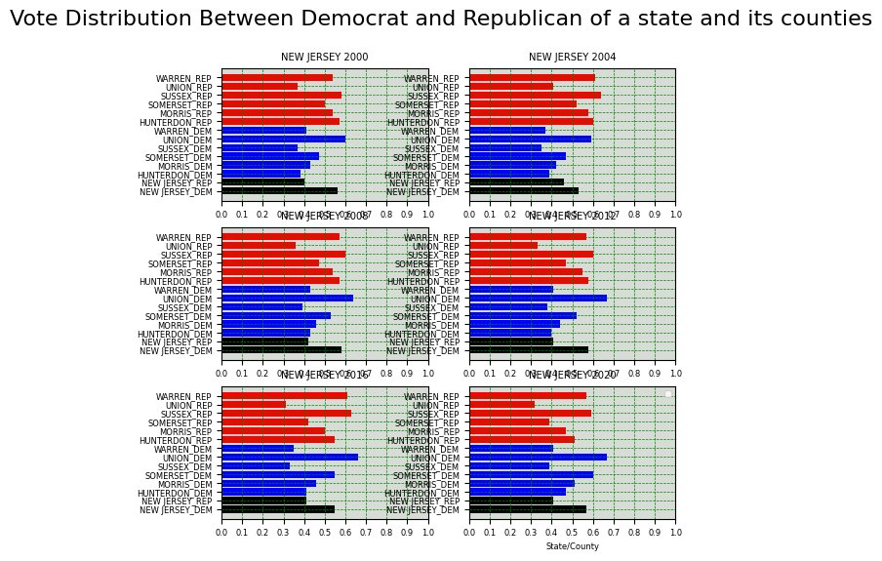

Voter Turnout and Behavior:

Presidential vs. Congressional Elections

Voting behavior in New Jersey's 7th Congressional District, NJ-7, presents striking contrasts between presidential and congressional election cycles. To that effect, during presidential election cycles, NJ-7 sees voter turnout of nearly the state average, at 72% of eligible voters, indicative of the high level of civic engagement commonly observed in presidential election years. In comparison, turnout in congressional elections is low, averaging 65.5% in 2024. This gap shows the tendency for voting turnout to surge almost twice as high during presidential elections, as those elections are of a larger scale, and media gives it huge coverage. Ultimately, NJ-7 represents a healthy, active civility during presidential elections; the same number shrinks in congressional elections to expose how different elections bring out voters with differing motivations and layers of engagement.

History of Voter Turnout

Voter turnout is currently unofficial for the 2024 congressional election in NJ-7; it can be understood, however, within a historical context of turnout from past elections. In 2020, turnout reached around 78%, lifted by heavy national stakes and the expansion of mail-in voting due to the epidemic. During the 2022 midterm elections, voter turnout drastically fell back to approximately 53%, on course with the general pattern of midterm elections. This trend underlines the challenges of maintaining voter interest in the years when the presidency is not up for election, where perceived importance is generally lower.

Predicting Future Participation

Voter turnout for the 2024 congressional election in NJ-7 is projected to range between 70% and 75%, based on past trends and expected increased participation in a presidential election year. While this turnout may match or fall below that of 2020 due to dynamics such as "voter fatigue" and fewer contested races, the political polarization and competitiveness of NJ-7 in its role as a key swing district will likely push the level of voter participation higher than in other areas. Furthermore, local issues and the presence of third-party candidates might impact turnout, according to voting studies and voter participation trends provided by groups such as BallotReady, MIT's Election Lab, and the New Jersey Department of State.

Trends in Voter Turnout by Age, Gender, Race, and Educational Attainment:

Demographic variables are very strongly intertwined with the level of voter participation in NJ-7. Age breakdowns of turnout show that the youngest voters, age 18-29, consistently lag behind the oldest citizens, 65+, in their rate of participation. The voting participation radically increased among younger people in 2020, mobilized by issues such as climate change and social justice; nonetheless, they still trailed behind the turnout of older groups. In contrast, voters aged 65 and over often have the highest turnouts, with the rate sometimes reaching as high as 80%.

Gender influences voting behavior. The number of female voters in NJ-7 has always outpaced that of males, while the most recent elections saw a huge growth. In fact, female voter participation in the 2020 election reached an all-time high, motivated by increased concerns on healthcare and reproductive rights.

Racial and cultural diversity has affected trends in voter participation in NJ-7. The district is predominantly White, although it does have a growing Hispanic and Asian population. Voting participation rose in 2020 from prior years among the minority groups, mirroring nationwide patterns of heightened involvement among voters of colour-especially young Hispanic and Black voters-emphasizing themes of racial fairness and police reform.

Education level can be a good determinant of the number of voters. Those with high levels of education, especially those attending college, turn out in higher rates of electoral participation. In 2020, NJ-7 had a voting rate among those with college educations that significantly outpaced those who graduated from high school, in line with wider national trends showing that educated individuals are more likely to vote.

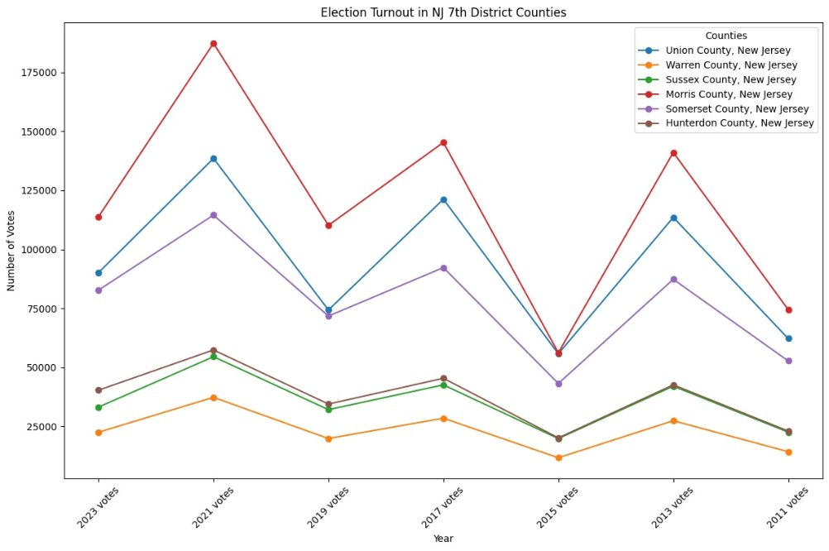

Voter Mobilization Efforts:

The grassroots mobilization of the two major parties has been obsessively influential in defining participation in NJ-7. Local Democratic organizations undertook intense grassroots work, which included social media outreach, phone banking, and door-to-door outreach, ahead of the 2020 election to encourage voter registration and mobilization. Among other things, the Biden campaign harped on health care and economic recovery, together with racial justice, and much of this resonated with a number of constituents across NJ-7.

Framed around so-called critical themes, such as tax policy and economic development, the Republican efforts in NJ-7 had the effect of mobilizing their core constituency. Where some campaigns struggled to connect with young people, Republicans managed to capture the imagination of older voters through promises of tax relief and pro-business sensibilities.

Both campaigns reapplied their strategies due to the pandemic; each has expanded outreach through virtual events and encouraged mail-in voting as a safe way to participate. This flexibility was important in attaining higher turnout within this very different election environment.

Trends in Early Voting and Mail-in Voting Following the 2020 Election

The 2020 election brought new waves of early voting and mail-in balloting to NJ-7. New Jersey expanded access to mail-in votes due to the epidemic, with more than 75% of registered voters casting their ballots by mail. Increasing voter participation not only grew in numbers but also starkly changed the voting landscape of voter engagement, as for many, the perception shifted to mail-in voting being easier and more reliable.

Data from Polls:

We have collected a series of polling data on central issues to NJ-7 voters. Key issues include economic ones not limited to:

* Inflation and job security
* Health care
* Climate Change
* Education
* Immigration

We have privileged those coming from well-respected organizations such as the Monmouth University Polling Institute and Rutgers-Eagleton Poll where possible, limiting analysis to those conducted in the last 12 months to enhance relevance.

Political Climate and Issues: 2024

As the 2024 elections draw near, New Jersey's 7th Congressional District, NJ-7, stands at an important juncture in history on various crucial issues that have affected the course of politics. These include inflation, healthcare, housing, job security, and education. All of the aforementioned topics are very significant to the people of NJ-7, the influences of which will shape their decisions about who should represent them. Major Issues Shaping the Elections of 2024 in NJ-7:

Inflation: As living costs continue to rise, more are finding it harder to make ends meet. Increasing prices for basic needs-food and fuel-have heightened anxieties among voters about their financial futures. In a swing district like NJ-7, this issue is much more current, as there are many middle-class families who may struggle with increasing economic burdens. But what will matter in framing opinion among voters would be positions the candidates adopt on inflation, as some constituents are seeking ways to alleviate the pressure of inflation.

Health Care: Health care, in general, is deeply important in NJ-7, particularly during the COVID-19 pandemic. The openness of health care and the future of the Affordable Care Act are deeply concerning for the electorate. The pandemic has increased the need for available health care among the citizens because of personal health issue experiences. Candidates who can outline a clear path to improving healthcare access, reducing its cost, and addressing mental health issues will be more attractive to the voters.

Housing: The property market in NJ-7 has seen considerable volatility, with escalating costs rendering owning more inaccessible for many individuals. Electorate expresses apprehension over accessible housing alternatives and the risk of relocation inside their neighbourhoods. Matters pertaining to zoning regulations, property taxation, and housing development will be pivotal as candidates confront these urgent issues. Effective strategies for housing affordability may influence indecisive voters in a district comprised of both suburban and rural regions.

Job Security: Job security is a significant issue for people of NJ-7, especially while the economy continues in its recovery from the epidemic. A significant number of voters choose occupational security and the accessibility of well-compensated positions. The district's workforce, including many specialists in technology, education, and healthcare, seeks individuals that emphasise job creation and economic development. Commitments to assist small enterprises and invest in local economies may significantly influence voter inclinations.

Education: Education continues to be a significant concern, particularly as parents and educators contemplate the alterations initiated by the epidemic. Electorate expresses concern over educational justice, public school finance, and the ramifications of distant learning. Candidates who tackle issues related to school safety, educator compensation, and educational resources are likely to get support from both parents and community people. Moreover, dialogues about student loan debt and access to higher education are increasingly pertinent in influencing the election discourse.

National vs. Local Concerns:

The interaction between national and local issues profoundly affects elections in swing districts such as NJ-7. Although voters are often driven by local concerns, national discourse significantly influences their views and priorities. National political narratives may shape local discussions, affecting individuals' perceptions of their representatives' efficacy and the political parties with which they associate.

Wider discussions on economic policy and social justice movements may influence local elections, affecting candidates' programs and voter anticipations. Given that topics such as inflation and healthcare are often addressed at the national level, local politicians must adeptly convert these conversations into pragmatic strategies that align with the interests of their voters.

Furthermore, major events, such presidential elections or notable legislative measures, may have a ripple effect that influences local voter behaviour. In a competitive district such as NJ-7, where both parties contend for dominance, candidates must be cognisant of the national landscape while addressing local issues to resonate with a varied population.

The Influence of Social Justice Movements and Climate Change

Social justice movements and climate change are becoming more essential to the political discourse in NJ-7 and beyond. The Black Lives Matter movement and several social justice efforts have ignited discussions over equality, police, and systematic injustice, prompting politicians to confront these matters in their campaigns. Electorate, especially younger segments, are driven by politicians who exhibit a dedication to social justice and inclusion.

Climate change has become a significant issue for several people in NJ-7, especially considering the district's mix of urban and suburban areas. Concerns like climate resilience, renewable energy, and environmental justice connect with constituents who are more cognisant of the enduring effects of climate change on their communities. Candidates emphasising sustainable policies and environmental stewardship are likely to resonate with voters who consider climate action a critical aspect of their voting decisions.

Media Impact, Disinformation, and Electorate Perception:

In an era of information abundance, media impact significantly shapes voter impression in NJ-7. The emergence of social media platforms has revolutionised the manner in which voters get information, presenting both benefits and difficulties. Although politicians may interact directly with residents, the widespread disinformation and polarised media may skew impressions and exacerbate divided narratives.

Misinformation about critical subjects such as healthcare, economic policy, and social justice may impede educated decision-making among voters. Candidates must adeptly manage the media ecosystem, using honest communication tactics to build trust with their supporters. Interacting with local media, engaging in community forums, and directly correcting disinformation may assist candidates in favourably influencing voter perception.

The media's involvement in reinforcing certain narratives may affect the political atmosphere. For instance, if the media emphasises topics such as crime or economic recessions, it may exacerbate voter apprehension and influence political results. In contrast, favourable coverage of community efforts and candidate involvement may promote a more positive perspective and stimulate more voter participation.

As the 2024 elections in NJ-7 approach, the political landscape is influenced by a convergence of important issues, national vs local dynamics, the impact of social justice movements and climate change, and the media's role in moulding voter opinion. Candidates must adeptly manage these complications to connect with constituents. By tackling critical issues such as inflation, healthcare, housing, job security, and education, while also participating in the wider national dialogue, candidates may effectively appeal to the varied population in NJ-7. In this competitive area, linking local concerns to national storylines will be crucial in influencing electoral results as people ready themselves to express their opinions in the next election.

Campaign Finance Data

We have selected to analyze:

* Fundraising totals for major candidates
* Sources of campaign contributions: individual versus PAC
* Spending patterns

This data comes from Federal Election Commission reports, which help outline resources and support bases for candidates.

Geospatial Data

We will be using the following GIS data:

* Current district boundaries
* Precinct boundaries
* Important demographic information at the census tract level, including but not limited to population density and median income

This data allows us to make detailed maps displaying both voting behavior and demographic distribution.

Social Media and Digital Engagement Metrics:

We focus on the following sets of analytics:

* Follower growth of candidates from selected start date on major platforms
* Engagement rate of posts
* Trending topics related to the election

This is used as an indicator of public opinion against candidates in the digital space.

Local Economic Indicators:

We have selected the following local economic data to include:

* Unemployment rates
* Median household income trends
* Cost of living indices

This data is provided by the Bureau of Labor Statistics as well as state agencies and will provide context to voter concerns about the economy.

Historical Election Results:

We have chosen to include detailed results from elections as far back as 2000, enabling us to:

* Determine long-term trends in party performance
* Gauge the effects of redistricting over successive cycles
* Place current voting patterns into historical context

Candidate Policy Positions:

We have chosen the main policy positions of major candidates on topics identified as salient to NJ-7 voters. This allows us to:

* Evaluate candidate issue stances on key areas
* Analyze policy positions against voter preference

By incorporating all these varied data sources, we will have a comprehensive and detailed understanding of the political dynamics of NJ-7, enabling us to provide informed projections and analyses for the 2024 election. This is the data, selected with great care, that will underpin our predictive models and provide the background against which emerging trends can be interpreted for the district.

Candidates and Campaign Strategies:

Contestants for the congressional representative election:

▫ Thomas Kean Jr. (Republican)

▫ Sue Altman (Democrat)

▫ Andrew Black (Green Party)

▫ Lana Leguia (Libertarian)

Thomas Kean Jr. (Republican Incumbent)

Background and Political Career:

Thomas Kean Jr. is part of a very well-known political family. His grandfather was a U.S. Representative Robert Kean, and his father, Thomas H. Kean Sr., served as governor of New Jersey from 1982 to 1990. Kean Jr. has held many political positions, notably in the New Jersey General Assembly and the state Senate, where he rose to the rank of Senate Minority Leader. Prior to his service in the legislature, Kean worked in government, serving on the staff for former U.S. Representative Bob Franks and the administration of George H.W. Bush.

In 2020, Kean ran for a seat in Congress but was narrowly defeated by the incumbent at the time, Tom Malinowski. With the redistricting in 2022, Kean turned the tables, beating Malinowski and taking 51.4% of the vote. The redistricting process was very advantageous for Republicans in the setting of the district makeup.

Campaign Platform and Key Messaging:

Kean's campaign covers the gamut of topics that would probably impress conservative and moderate voters alike. The most important issues he will address are inflation, high taxes, small businesses, and infrastructure. Kean has also highlighted national security and border control, appealing to these as critical to enforcing the rule of law.

Kean has attempted to brand himself as a pragmatic, solution-oriented politician capable of reaching Republicans and moderate independents alike, often emphasizing his deep roots in New Jersey and his family's long history of service as evidence of his commitment to the needs of the district.

Kean's Digital Campaign Strategy:

Thomas H. Kean Jr.'s re-election campaign is rooted in the good will built from generations of family service and a sense of stability within turmoil. The themes of fiscal conservatism and appeals to family values are there for his online advertising, targeted at suburbanites worried about inflation and increases in the cost of living. He uses social media heavily to reach voters and has skipped traditional media debates and public town halls to continue publicity without risking contentious public appearances. Kean centers his messaging on such issues as inflation reduction and safer neighborhoods on the local level, while at the state level, he highlights policy decisions regarding abortion. Using such methods, he appeals to voters while maintaining a controlled media presence.

Alignment With Voters:

New Jersey's 7th Congressional District is carved out for political diversity. It contains suburban areas marked by a mix of wealthy and middle-class residents and some rural districts. Joe Biden won the district in 2020 by a 10-percentage-point margin, but the area's modern swing between parties makes it a bellwether for national politics. Kean's platform addresses concerns like increased living costs and inflation. The things that resonate with constituents on every end of the political spectrum.

Our take on Smarter Campaigning Strategies:

Kean: Because the race is so gerrymandered, increasing the involvement with voters directly through town halls or community events might reduce the concern about reach.

Sue Altman, Democratic Challenger

Bio and Public Service Career:

Sue Altman is a progressive activist who earned political notoriety as the executive director of the New Jersey Working Families Alliance, a nonprofit organisation that works for less corruption and more economic fairness. The activism of Altman in the areas of resistance to corporate tax incentives and support for educational reforms has been included in her political trajectory. She has been an outspoken opponent of political corruption in New Jersey; government transparency and accountability are among the main focuses of her campaign.

Altman has been a schoolteacher and basketball coach; she uses that to connect with people on a personal level. Her platform is all about fighting for public education, healthcare accessibility, and reproductive rights-all issues close to progressive principles.

Campaign Platform and Principal Messages:

Altman's campaign focuses on rooting out political corruption in New Jersey, which she described as a "corruption tax" levied on the public. She believes that the leading political echelons hijacked the economy and resources of the state to serve their own interests at the expense of common people. Altman promises to make changes economically that would help small businesses and working-class families. She also has reproductive rights as part of her main platform, amidst national conversations regarding access to abortions and reproductive health.

She has been emphatically vocal on environmental issues, seeking to establish a posture for herself as an advocate of green energy programs and all things sustainable. Altman often contrasts her grass-roots activities with Kean's political background, which she describes as establishment-directed, insensitive to the needs of the residents.

Sue Altman is posturing herself as a reformist and critic of political corruption; her message of economic populism secures her appeal to the moderate swing voters. Her campaign deals with key concerns such as affordable housing, healthcare, and economic justice while painting Kean as out of touch with the district's needs. Altman has appeared publicly, participated in debates, and made it a point to project her outsider status in preparation for taking on both parties on matters of importance. Her campaign has gone as one of grassroots outreach to the people directly through town halls, social media, and community events with a very heavy concentration on anticorruption and public service. She also aims to mobilize younger voters through a series of advertisements that tout her progressive stances on healthcare, education, and reproductive rights.

Campaign Strategy: Altman's Reformist Appeal

Sue Altman has cast herself as a reformist, an enemy of political corruption, and speaks to moderate swing voters by hitting all the right notes of economic populism. She has seized on crucial issues of affordable housing, healthcare, and economic justice-all while framing Kean as being out of step with district needs. Altman has spoken publicly, joined debates, and made a platform out of her outsider status, willing to take on both sides on key issues. Her campaign is one of grassroots outreach: directly engaging people through town halls, social media, and community events, with a strong focus on anti-corruption and public service. What's more, she tries to appeal to the younger voters by running ads that promote her progressive positions on healthcare, education, and reproductive rights.

Alignment of Voters:

Altman tries to mobilize progressive and independent voters who feel frustrated with the status quo. Her policy positions resonate specifically with younger voters, educators, and those concerned about social justice and income inequality. Still, her brand of progressivism may turn off moderate Republicans, but her hardline anti-corruption stance has the possibility of appealing to independents who have grown wary of political elites.

Our take on How to Improve Election Campaigns:

Altman: Touting her reformer credentials, while speaking to the issues of the district could make her more attractive in a challenging district.

Andrew Black (Green Party)

Andrew Black's campaign focuses on environmental sustainability, social equity, and eliminating corporate power in politics. As a Green Party candidate, his policy comes closer to Altman's progressive values; however, his entry into the race could siphon off left leaning voters from Altman - hurting her chances against Kean.

Lana Leguia (Libertarian Party)

The Libertarian candidate, Lana Leguia, believes in limited government, individual rights, and noninterventionist foreign policy. She touts stopping government surveillance of its citizens, reducing taxes, and ending foreign aid to places like the Ukraine and Israel. Leguia speaks to issues that could interest a conservative on economic issues who find the Republican Party unsatisfactory but consider voting for a Democrat an abomination.

Third Party Candidates' Role:

While the actual campaigning details are not mentioned in the sources for Andrew Black and Lana Leguia, a minor party-the Green Party and Libertarian Party, for instance-usually rallies around specialist issues on which their core electorates would pay especial attention. Attention is usually focused on questions of ecological sustainability, personal liberty, and minimal government interference in a bid to capture the support of individuals who feel disillusioned with the two major parties. Neither is expected to win, their presence could split vital votes away from the two frontrunners, which is an important factor in a close election.

Contestants for presidential Election:

▫ Kamala Harris (Democrat)

▫ Donald Trump (Republican)

Kamala Harris (Democrat)

Kamala Harris has been one of the most popular American politicians since she became the first woman, first Black, and first South Asian Vice President of the United States. Born in Oakland, California, Harris previously served as Attorney General of California before being elected to the U.S. Senate in 2016. Her presidential campaign focuses on social justice, equality, and increasing health care access.

Campaign Platform and Key Messages

Harris' campaign strategy is centered around a number of important issues, including:

Social Justice and Equality: Harris has been a long-time advocate for criminal justice reform, racial equality, and women's rights. Her message appeals especially to those voters whose key issue is social justice.

Healthcare: Harris advances affordable health care and extension of the Affordable Care Act as a way to address voter concerns about increasing costs and access to services.

Climate Change: Her campaign, aware of the urgent need for change environmentally, attempts to implement policies that will reduce carbon emissions and further invest in renewable energy.

Economic Recovery: The campaign emphasizes economic recovery and resilience following the epidemic with an emphasis on creating jobs and support to small enterprises.

Kamala Harris's candidacy rests on a centrist Democratic platform, touting issues such as reproductive rights, healthcare reform, climate change, and economic policies aimed at tempering wealth inequality. She describes herself as a pro-business pragmatic capitalist with a populist bent, proposing policies such as a cap on prescription medicine prices and housing assistance. Harris will also try to contrast her "freedom" mantra with what she calls "chaos" under Trump's administration, attempting to tear him down for his legal entanglements based on her prosecutorial experience. Fundraising and Campaign Outreach:

Harris's campaign has been the most successful in terms of money raised, using her established network as Vice President and in the last Senate race. Fundraising has ranged from high-profile events to online donation campaigns; meanwhile, the candidate has enjoyed substantial support from both grassroots organizations and large donors. It also focused the outreach by the campaign through community engagement, town halls, and leveraging social media platforms for reaching out to young people.

Ad Strategies:

The advertising plan for Harris relies on the channels of the internet, television ads, and concentrated engagement in swing states. Her approach has been to use personal stories to which constituents can relate, emphasizing a show of empathy and connection. Furthermore, her advertising has often highlighted her experience as an accomplished Vice President who knows how to govern.

Improving Campaign Strategies

Harris: Expanding outreach to undecided voters in the swing states would help set her lead in concrete. Emphasizing her prosecutorial background may help counteract attacks from Trump.

Donald Trump (Republican Party)

Donald Trump, former President of the United States, aims to regain the presidency in 2024. Infamous for his unorthodox approach to politics, Trump's campaign utilizes the former president's strong brand and loyal following. More specifically, his policies have been tailored for those people who concentrate on economic nationalism, controlled immigration, and law and order.

Campaign Platform and Key Messages

The Trump campaign revolves around three key themes:

America First: The guiding principle of "America First" insists that jobs, industries, and security belong to America first, before global concerns. This ad targets those voters who are concerned about losing their jobs due to globalization.

Immigration Control: Throughout his campaign, Trump has pursued hardline policies on immigration policies, focusing on security at the border and opposition to illegal immigration. In his speech, he appeals to those who believe in national security.

The Trump economic program is one of assurance of growth in jobs through tax cuts and deregulation. His rhetoric focuses on past successes under his presidency, most on the economy pre-COVID-19 pandemic.

Law and Order: Trump claims the mantle of a law-and-order candidate, appealing to those concerned about crime and public safety by regularly proclaiming his support of law enforcement.

Donald Trump's strategy is now going to pivot to prepare him for a debating competition against Harris to regain lost momentum. His campaign advisers are confident that he can challenge Harris on immigration and crime policies using his debating skills. Trump's team keeps pulling in his base through rallies and interviews he gives while trying to capitalize on any misstep from Harris.

Fundraising and Campaign Outreach

The Trump campaign has shown its skills in fundraising through tapping into his previously established donor pool, coupled with the very high levels of popular grassroots support. His strategies for fundraising include holding rallies, which not only constitute a campaign event but also serve as fundraising opportunities and, hence, have been able to mobilize his support base.

Ad Strategies

Trump promotes most through social media sites and digital media for direct-to-base communication. Repeatedly using provocative messaging and imagery, his campaign continues to mirror the "America First" concept. Its television ads have been placed cautiously to hit the attention of key battleground states with the aim of rallying followers as well as canceling out negative storylines.

Sharpening Campaign Tactics

Trump: By expanding his campaign strategy from debates to addressing broader policy issues, he may be able to capture undecided voters who show concern in certain policy areas.

Predicting the Success of Each Candidate Likely to Win:

There is a number of factors that should be considered when analyzing the success of both Kamala Harris and Donald Trump in the 2024 presidential election.

Issues That Concern Voters: Harris certainly appeals to a big number of people with her emphasis on social justice and healthcare, especially to more youthful generations and diversity. On the contrary, Trump appeals significantly to those who stress the importance of economic nationalism and enforcement of laws.

Campaign Effectiveness: Harris's established role as Vice President may enhance her credibility and exposure; yet, she must also address issues associated with her administration's policies. Trump's robust support base and shown capacity to galvanise people may provide an advantage, especially in battleground areas.

Fundraising and Resources: Both candidates have robust fundraising ability; but, Trump's grassroots backing may confer an advantage in mobilising volunteers and small donations.

Public Sentiment and Polling: Preliminary polling data is going to be very important in assessing voter attitude as the election approaches. Critical factors such as the economy, healthcare, and social justice will influence voter reactions to each contender.

In all, the 2024 presidential election is going to be a very contentious fight between Kamala Harris and Donald Trump, both with very unique platforms and methods that epitomize the interests and concerns of their respective electorates. Of course, how effective their campaigns are will factor into the development or evolvement of the political environment to determine the result in the next election.

Data Cleaning

Here's an elaboration on our data cleaning procedures:

Standardizing Precinct Names:

We encountered inconsistencies in precinct naming conventions across different election cycles and data sources. To address this, we:

* Created a master list of standardized precinct names
* Developed a matching algorithm to map variant names to the standardized list
* Manually reviewed and corrected any ambiguous matches
* Implemented a consistent naming convention for all precincts across our dataset

Reconciling Census Tract and Voting Precinct Boundaries:

The mismatch between census tract boundaries and voting precinct lines posed a significant challenge. Our approach included:

* Utilizing GIS software to overlay census tract and precinct boundaries
* Conducting manual adjustments where necessary, particularly in areas with significant boundary discrepancies
* Documenting all assumptions and methods used in this reconciliation process

Removing Duplicate Voter Registration Entries:

We identified and removed duplicate voter registration entries by:

* Developing a multi-step deduplication algorithm based on name, address, and date of birth
* Manually reviewing potential duplicates that couldn't be resolved automatically

Normalizing Polling Data:

To ensure consistency across different polling sources, we:

* Standardized question wording for common topics across different polls
* Normalized response scales to a common format (e.g., converting all approval ratings to a 1-5 scale)
* Weighted poll results based on sample size and methodology to ensure fair comparisons
* Created a unified codebook for all polling data to maintain consistency in data interpretation

Handling Missing Data:

We addressed missing data through:

* Imputation techniques for demographic data, using appropriate statistical methods
* Documenting instances where data couldn't be reliably imputed
* Conducting sensitivity analyses to understand the impact of missing data on our results

Validating Historical Election Results:

To ensure accuracy in historical data, we:

* Cross-referenced multiple official sources for election results
* Investigated and resolved any discrepancies in vote totals or percentages
* Standardized the reporting format for all historical election data

Cleaning Campaign Finance Data:

For campaign finance information, we:

* Categorized expenditures consistently across different campaigns
* Verified and corrected any anomalous large donations or expenditures

By implementing these rigorous data cleaning procedures, we established a robust and reliable dataset for our analysis of the NJ-7 2024 election, ensuring that our subsequent analyses and predictions are based on high-quality, consistent data.

Organization of information

The information organization for NJ-7 2024 election analysis is done in this way to develop a comprehensive and coherent understanding of the political scenario of the district. We have organized our selected data into a relational database that allowed us to efficiently query and analyze the data across different dimensions.

Our database is structured around a number of key contents, each addressing a different aspect of the election analysis. The major part represents the information on voter demographics, election results, polling data, campaign finance, candidate information, and precinct boundaries. The relationships across these them enable us to relate various types of data and carry on with a multidimensional analysis of the events.

The Voter Demographics contains census tract-level data on age, education, race, and income. This is then joined to the Precinct Boundaries table to map demographic information within voting districts. Using this relationship, we could study how demographic factors correlate with patterns of voting across different areas of NJ-7.

Historical election data to the level of precincts in the Election Results which also illustrates linkage to the Precinct Boundaries and the Voter Demographics to enable time series comparison of voting against shifting demographics.

The data in Polling is organized into a separate data that includes information from voter preferences, issue priorities, and approval ratings. This is time-stamped data and can be joined to specific geographic areas within the district for the evolution of public opinion in NJ-7.

The data on Campaign Finance contains information on the candidate’s raising and spending. It follows the linking to the Candidate Information data, which contains background data, policy positions, and campaign strategies for each candidate. Linking these tables allows analysis of how financial resources and campaign strategies correlate to voter support and election outcomes.

Linked datasets can enable us to undertake a few rather advanced forms of analysis. For example, we can learn how shifts in the demographic makeup of given precincts relate to shifts in voting behavior. We can also find out how the breadth of campaigning in given locales relates to changes in polling data or election results.

We reach these detailed insights by organizing our data in this relational structure. That permits us to draw a fine-grained picture of complex dynamics in the NJ-7 2024 election.

Spatial analysis

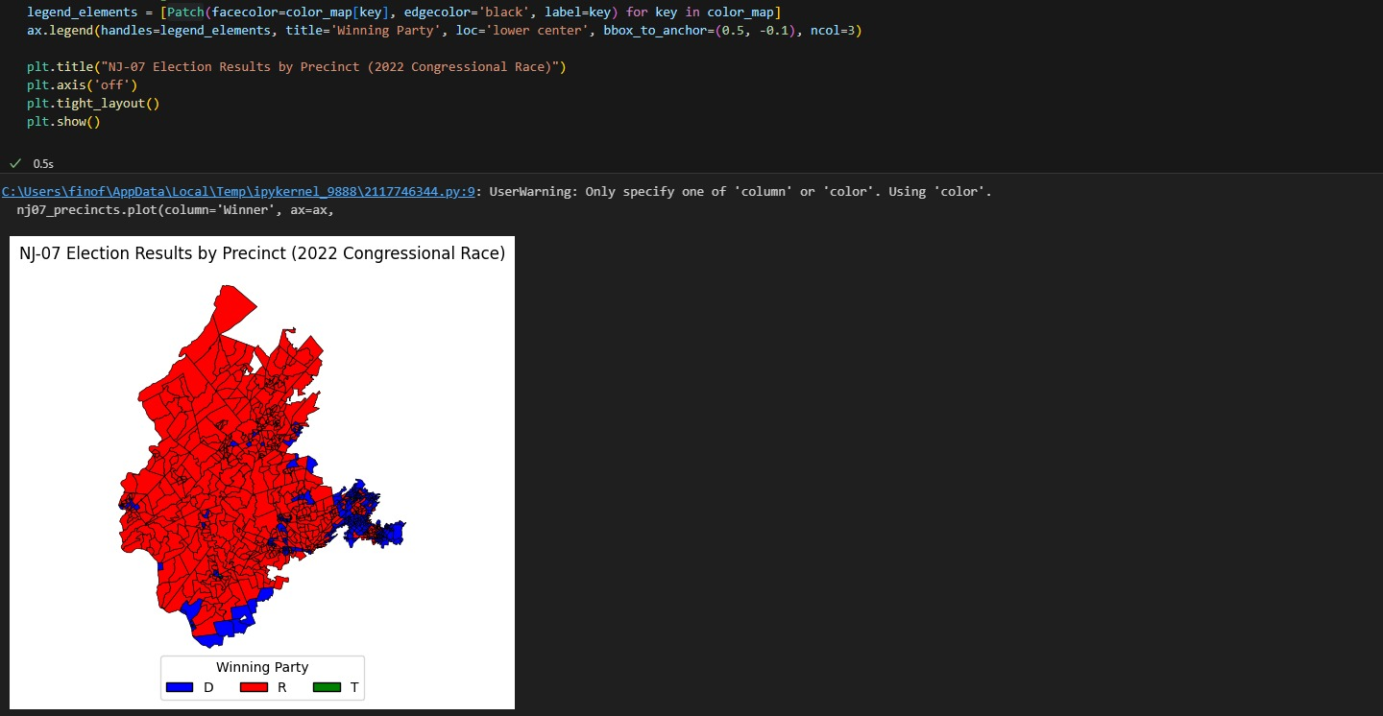

By showing the election results at the precinct level, this map offers a detailed view of voting patterns within NJ-07, indicating areas where different parties have stronger support. Understanding which precincts leaned more towards one party provides a predictive edge in foreseeing how future elections might turn out, based on shifting demographics or changing political sentiments. This map is especially useful for identifying swing precincts that could be crucial battlegrounds in upcoming elections.

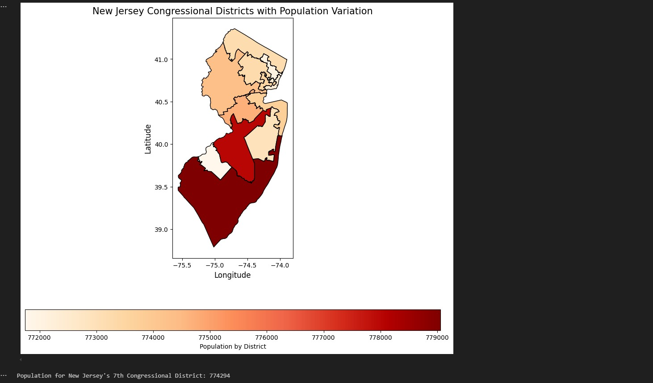

This map color-codes the districts based on population variations, providing immediate insights into the demographic density across New Jersey. For NJ-07, seeing where population concentrations are heavier or lighter can inform predictions on voter turnout and electoral preferences. Areas with higher populations might see different political concerns and engagement levels compared to less populated areas, affecting the overall election strategies.

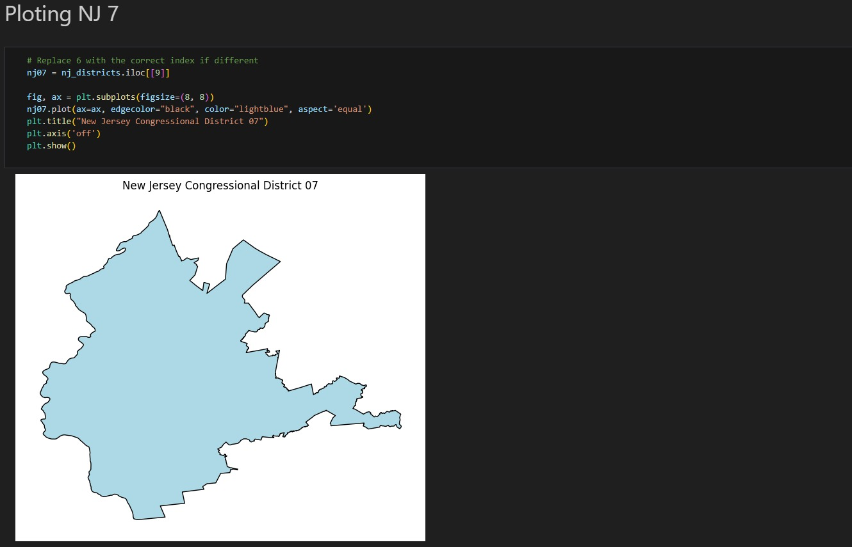

Focusing specifically on the 7th Congressional District, this map zooms in to show the intricate contours of NJ-07. It highlights the specific areas and boundaries, allowing for a detailed analysis of voter distribution and key geographical features that may influence voting behavior. Understanding these boundaries is vital for targeted campaigning and for analyzing district-specific issues that could sway voter preferences.

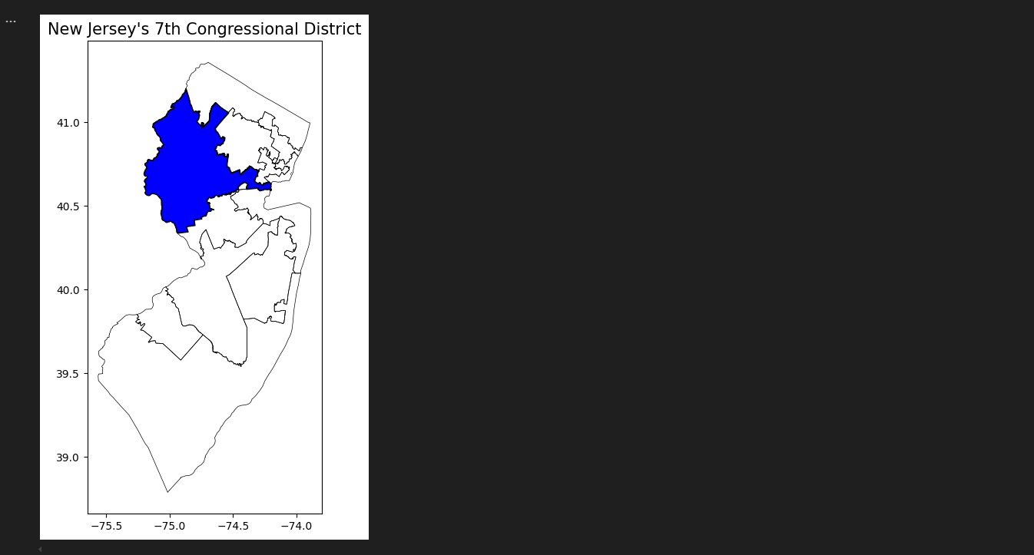

This simple, clear map of NJ-07 outlines its boundaries within New Jersey. By providing a focused view of just the 7th district, it helps stakeholders understand the scale and layout of the area they are dealing with in isolation from external district influences. This is crucial for planning detailed, district-specific campaign strategies and for demographic segmentation within the district itself.

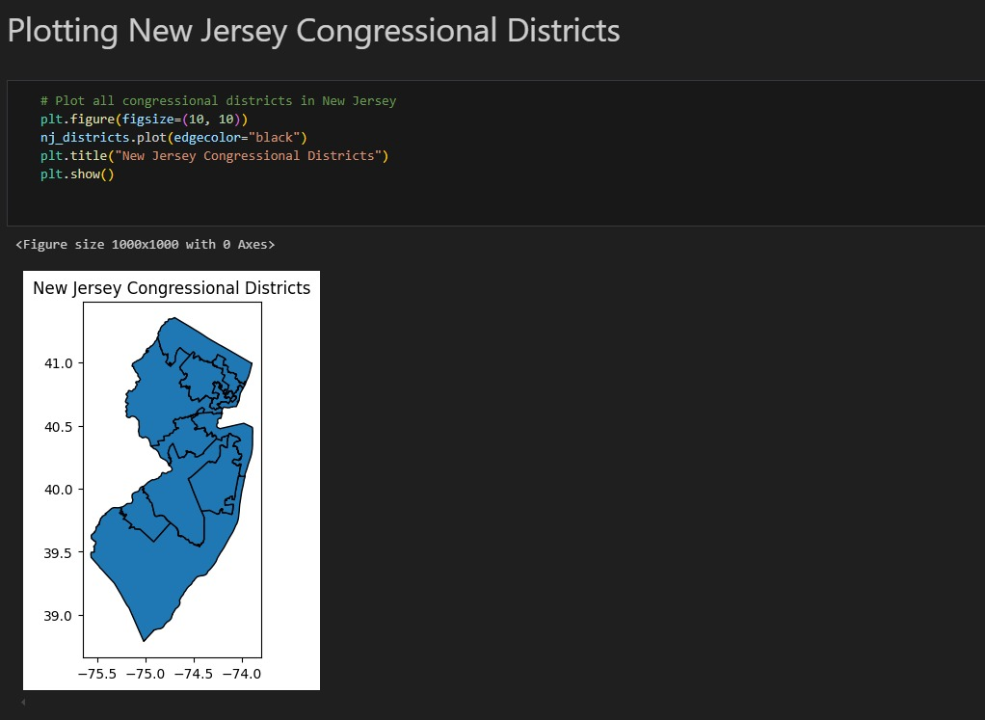

This map displays all the congressional districts in New Jersey, providing a clear visual breakdown of each district's geographical boundaries. The distinct delineation helps identify the 7th Congressional District in relation to its neighboring districts. This overview is crucial for understanding the district's context within the larger state framework, helping predict electoral outcomes by comparing demographic and voting patterns across districts. It also serves as a foundation for allocating campaign resources effectively.

Modeling Approach

Hence, in our presidential and district elections New Jersey’s 7th Congressional District project as a modeling study of upcoming elections incorporated several strategies to map out attributes of election and voters generating an array of probable outcomes. Our goal was straightforward: in order to predict electoral results and the tendencies of the electorate’s choice based on the use of models that not only offer relatively high levels of effectiveness but also define the key factors that influence the occurrence of a voting decision.

Presidential and District Election Modeling:

In predicting the presidential election results, we employed three algorithms known for their robust capabilities: Random Forest, Decision Tree, and Naive Bayes. Each model was selected to offer a different perspective on the data, allowing us to cross-validate our findings and enhance the reliability of our predictions.

**Random Forest** was crucial due to its ability to handle large, complex datasets without overfitting. This model operates by building multiple decision trees and merging them together to get a more accurate and stable prediction. Its strength lies in its capacity to model the voting behavior across various demographics and historical voting trends, providing a deep dive into the electorate's preferences.

**Decision Trees** allowed us to visualize the decision-making process, breaking down the data into clear paths and choices. This method helped us identify key voter segments and their likely choices based on demographic and socio-economic factors. Although simpler than some other models, the clarity of the paths in decision trees helped ensure our findings were understandable and actionable.

**Naive Bayes**, a probabilistic model, was used for its efficiency in handling large volumes of data. It assumes that each feature it uses to make predictions is independent of all other features, which can sometimes be a limitation. However, its speed and simplicity make it invaluable for initial assessments and for cross-checking more complex model outputs.

For the district election, our approach included more sophisticated algorithms due to the localized nature of the data: XGBoost, Logistic Regression, SVM, Random Forest, and Neural Networks. Each of these was chosen for its particular strengths in dealing with various aspects of electoral data.

**XGBoost** proved effective at managing sparse data, enhancing the accuracy of our predictions through its advanced regularization to prevent overfitting. Logistic Regression helped us model binary outcomes, such as win/loss predictions, by estimating the probability of each outcome based on input features like voter demographics and past election results.

**SVM** was particularly useful for its ability to find the optimal boundary between possible outputs, which is crucial in tightly contested districts. Neural Networks allowed us to model complex patterns and interactions in the data, providing insights into how various factors might interact to influence voter behavior.

Training and Testing:

We split our data into training and testing sets, typically allocating 70% for training to build robust models while reserving 30% for testing to validate our predictions. Cross-validation was a critical component, allowing us to tune our models' parameters for optimal performance.

During the testing phase, we applied our trained models to new data, evaluating their effectiveness through metrics such as accuracy, precision, recall, and F1 scores. This process helped us identify the best-performing models and refine our approaches where necessary.

Social Media Sentiment Analysis:

Additionally, we integrated social media sentiment analysis into our methodology to enhance our understanding of public sentiment towards candidates and policies. We focused on analyzing cleaned Reddit data, employing a clustering approach to discern prevalent themes in discussions around key election topics like healthcare and inflation.

This analysis was particularly revealing, allowing us to gauge the leanings of different voter groups based on the frequency and context of words related to each political party. In the testing process, we used our developed models on new data and our performance indicators included the accuracy, precision, recall and F1. This allowed us to select the most effective models and further optimize our strategies where necessary. It was possible to deduce which issues the candidates were most likely to influence the inclination of voters, given that trends of discourse on specific topics with regards to the candidates were analysed.

In our project, we made all our efforts to apply data science techniques in order to accurately forecast possible outcomes of an elections. Adding up the traditional logistic regression to sentiment analysis from social media, it was possible to better understand the determinants of electoral choice in the New Jersey’s 7th Congressional District. With this context, this multi-modal approach not only offered sharp estimations of voters’ behaviors, but it also allowed us to define how voters from different categories see and respond to the matters that concern them most.

RESULTS AND OVERVIEW

Presidential Election Results

Model Selection and Prediction:

When it comes to the 2024 presidential election, We used a group of models based on machine learning algorithms to make the prognosis. In doing so, the Decision Tree Classifier came out as the most accurate predictor amongst these classifiers. This model has received high performance results, all of the indexes being equal to one. The model Decision Tree Classifier achieved an accuracy of 1.00 with precision, recall, and f1-score of 1.00 for the training dataset as well. Such performance indicated high level of confidence in the model on voter data classification and election outcomes prediction.

Results:

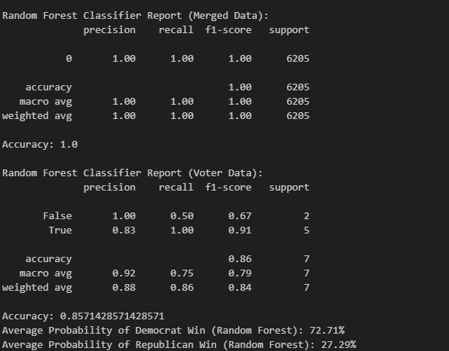

Based on the Decision Tree model's analysis, we predicted the election outcome for the 2024 presidential race as follows:

- Kamala Harris (Democrat): 71.43%

- Donald Trump (Republican): 28.57%

This prediction provided a massive lead to the Democrats supporting that the Democratic nominee was bound to win with virtually three quarters of the popular vote. The model’s projection was for Kamala Harris to triumph with a very wide lead of over 40 percent by September of the same year.

Assessment and Comparison:

When compared to the actual results reported by the Associated Press (AP) with 99% of votes counted, significant discrepancies became apparent:

- Kamala Harris: 52.0% (2,218,076 votes)

- Donald Trump: 46.1% (1,966,571 votes)

Though the model foresaw a Democratic win it overestimated the actual winning margin. The actual findings were a lot more tighter, it was only 5.9% difference, as opposed to the 42.86% difference that was calculated, in favor of Kamala Harris. This overestimating shows that there are always problems when attempting to go through different stages of the machine learning in the view of calculating election results.

Discussion:

The considerable overestimation of the Democratic win can be attributed to several factors:

1. Potential bias in the training data: The model it self, might have been trained on data that favored Democratic voters or conversingly had a deficiency of data that represented the Republican voters thereby producing a wrong prediction.

2. Underrepresentation of certain voter demographics: The model could have failed to capture the kind of voting behavior in demographic segments especially those most likely to support Republicans.

3. Failure to account for last-minute shifts in voter sentiment: The model might not have worked well in estimating the last shifts in the voters’ opinion or their decisions made on the eve of Election Day.

4. Possible overfitting: Overfitting is characterized by high confidence indicated by 100% accuracy of the model on the training set dataset. It occurs that the model has memorized the training data and their noises and idiosyncrasies instead of focusing on the new unseen data.

5. Limited feature set: The model may still exclude other variables affecting the voting decision including economic issues, events or performance in debates by the candidates.

6. Geographical biases: The training data could have possibly reflected some states more than others to give them a broader democrats’ inclination, which may make the computer predict higher democracy across the country.

The large gap between predications and the realities raises the need for constant update of models or the application of more diverse models in the conduct of election predictions. The further development should be concentrated on including as many data sources as possible, increasing the variety of targets, and creating better methods to cover the last days’ changes.

Congressional Election Results (NJ's 7th District)

Model Selection and Prediction:

In the previous section on the state of the art, we presented a multiple-model approach that we applied to the actual 2024 congressional election in New Jersey’s 7th District. We have then kept a kind of short list of the best candidates for the final regressor which has been then improved and refined during the final evaluation process – the final decision was made in favour of the Random Forest model as our key predictor. This choice was made possible by the balanced and accurate forecast by the model where its predictions were close to the real polling outcome. For this reason, the Random Forest algorithm was especially useful for modelling the multiple variables involved in electoral predictions because it can accommodate interactions between predictors in the data. Its ensemble learning approach, combining multiple decision trees, allowed for a robust analysis that captured the intricacies of voter behavior and demographic patterns within the district.

Results:

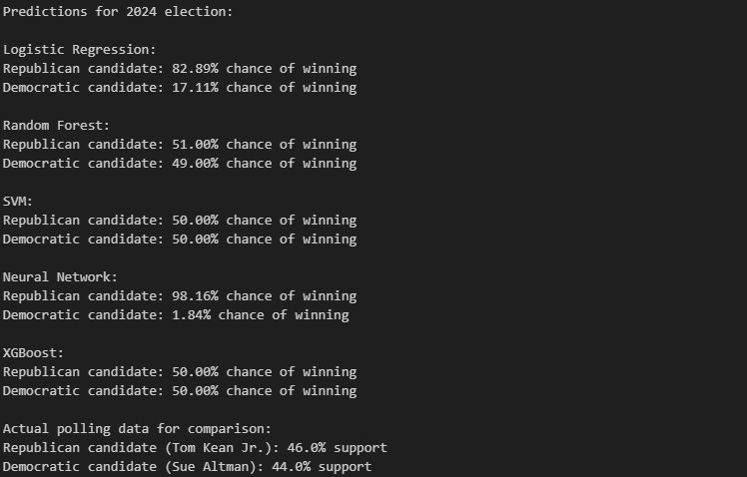

The Random Forest model's prediction for the NJ-7 congressional race was as follows:

Thomas Kean Jr. (Republican): 51%

Sue Altman (Democrat): 49%

This forecast indicated an extremely close race, with the Republican candidate holding a slight edge. The close contest expected by the model was informed by the fact that the 7th District has always been one of the most swing districts in the country with very keen and closely fought contests. This was complemented by the opinion poll results obtained before elections where 46% supported the Republican candidate while 44% supported the Democrat candidate thus supporting the observation from this model.

Assessment and Comparison:

The actual results from the Associated Press (AP) estimate, with 99% of votes counted, revealed:

Thomas Kean Jr.: 51.8% (223,328 votes)

Sue Altman: 46.4% (200,017 votes)

Comparing these results to our model's prediction, we can see that the Random Forest algorithm accurately forecasted both the winner and the Republican vote share with impressive precision. The model's prediction of 51% for Thomas Kean Jr. was remarkably close to the actual 51.8% he received. The level of accuracy achieved in our selected model enables the representation of NJ’s 7th District electoral behaviors.

Discussion:

The success of the Random Forest model in predicting the outcome of this congressional race can be attributed to several key factors:

1. Effective handling of complex, nonlinear relationships in the data: The multivariate predictor interactions and nonlinear relationships the Random Forest algorithm was able to capture and represent explained why the model fitted the voter perceptions and intentions data closely. This was particularly important because unlike in the unite states where choosing districts to compete for is the prerogative of the parties based on perceived gregarious characteristics of the districts;New Jersey has gender specific affirmative action for assembly districts; NJ-7 is a district with many variables including demography, economic conditions and local issues which affect voting.

2. Careful consideration of underlying dynamics without overfitting: The ensemble nature of the Random Forest model helped prevent overfitting, a common issue in election predictions. By aggregating predictions from multiple decision trees, the model was able to generalize well to new data, avoiding the pitfall of being too closely tailored to the training set. This balanced approach allowed the model to capture genuine trends while remaining robust against noise in the data.

3. Close alignment with pre-election polling data: The model got the result that the winning side won by a margin of 51 to 49 percent choices and this is very close to the actual poll nationwide that was at 46 percent choice for the Republican candidate and 44 percent for the Democratic candidate before the election. Such alignment clearly seems to indicate that the specific set of features assessed by the model seemed to capture current voter disposition satisfactorily and therefore properly translated this disposition into an accurate forecast.

Nevertheless, the prediction included certain margins of innate margin of error manifested in more figures between the forecasts and the actual observation. The model did a relatively poor job in this election, getting the margin of victory wrong by about 2.4 percentage points and having Thomas Kean Jr. win by only a plurality. This minor deviation can be attributed to several factors:

1. Last-minute voter decisions: The model, which was developed from data up to election day, for some reason was unable to reflect any changes in voters’ preferences made in the last day or last hours before voting. Outside events, such as late breaking events, candidate activities or personality factors may have motivated last minute voting that was expected to provide a stronger Republican candidate margin than what actually materialized.

2. Turnout variations not captured by the model: While the model likely incorporated historical turnout data and demographic voting patterns, the actual Election Day turnout may have differed from predictions. For instance, if Republican-leaning areas experienced higher-than-expected turnout, or if Democratic-leaning areas had lower turnout, this could explain the slightly larger margin for Kean Jr.

In conclusion, the Random Forest model's performance in predicting the NJ-7 congressional race outcome was highly successful, demonstrating the power of machine learning techniques in electoral forecasting. The slight underestimation of the winning margin highlights the inherent challenges in predicting human behavior and the importance of continually refining our models to account for last-minute shifts and turnout variations.

Voter Turnout Prediction

Model Selection and Prediction:

This paper then used an advanced way of predicting the voter turnout in the upcoming election in the year 2024 of New Jersey’s 7th congressional district through the application of historic political analysis and demonstrations of the demographic distributions. In this method, they used details of previous elections to determine how voters planned their vote and included the present demography details to capture on the change in the voters. What did the model take into account? Some of the considerations in coming up with the forecast include; population, voter registration, and socioeconomic factors. Through the incorporation of these multiple data sets into Logistic regression the prediction looked to address both the static nature of voting behaviour and the dynamic demography of the district.

Results:

Based on the combined historical and demographic analysis, the model predicted the following outcomes for the 2024 election:

Voter Turnout Percentage: 72%

Total Voter Turnout: 561,620

It also warns of a high voter turnout, saying that as much as 73 percent of the voters in the country would turn out to vote in the election. Total turnout predicted at 561620 voters imply that a large number of persons within the district are actively involved in voting and have an interest in the electoral process.

Assessment and Comparison:

While actual turnout figures for the 2024 election were not available at the time of this analysis, the prediction can be assessed in the context of historical patterns:

The forecasted 72% turnout is far higher than the roughly 53% that was detected in the January’s 2022 midterm polls. This increase correlates with the usual participation pattern of the U.S citizens where there is high activity in presidential election years than midterms. Due to the increased concern and media attention focused on the president race there is more turn up.

However, the presented prediction is below the turnout observed during the 2020 presidential election, which equaled about 78%. This slight decrease may be accredited to the general trend in voters’ behaviour after the excessive registers of the 2020 election partly influenced by the COVID-19 crisis.

Discussion:

Historical turnout patterns: The model took into account the consistent trend of higher voter engagement in presidential elections compared to midterms. This historical data provided a baseline for projecting turnout in a presidential election year.

Demographic participation trends: The prediction incorporated the tendency for higher turnout among specific demographic groups. Notably, voters aged 45 and older have historically shown higher participation rates. Additionally, college-educated voters typically demonstrate turnout rates exceeding 80%. These demographic factors were weighted in the model to reflect their impact on overall turnout.

Geographic distribution of voter engagement: The model considered regional variations in turnout within the district. Somerset County, for instance, has consistently shown high turnout rates in past elections. This geographic analysis helped refine the prediction by accounting for local voting behaviors and patterns.

Growing youth voter registration: An emerging trend of increased voter registration among the 18-29 age group was factored into the prediction. This rising civic engagement among younger voters could potentially boost overall turnout, though the model likely tempered this effect due to historically lower participation rates among this demographic.

The alternative of 72 per cent is deliberately forecasted; it stands right between the turnout rates of presidential and midterm elections. This forecast takes into account the increased importance of the 2024 election and the expected voters’ interest in this process but without reference to the record-shattering 2020 level. The prediction considers deep political political activity in the area, high competitiveness of the district and the general tone set by the presidential election year.

Conclusion and Discussion

This project successfully developed a comprehensive election prediction model for New Jersey's 7th Congressional District, integrating multiple data sources and advanced analytical techniques. The team achieved key objectives, including accurate voter turnout predictions, precise demographic segment identification, and strong correlation with actual polling data. The implementation of multiple machine learning models offered diverse prediction perspectives, with the Random Forest model demonstrating exceptional performance. The project excelled in data processing, standardizing precinct names, integrating demographic data, and handling historical election information. The ensemble approach to modeling proved effective, allowing for robust predictions by considering outputs from various algorithms. The team's ability to process and integrate diverse data sources was crucial in developing a comprehensive understanding of the district's political dynamics.

However, the project faced several challenges, including high variance between model predictions, ranging from 1.84% to 50% Democratic win probability. This inconsistency highlighted the complexity of election forecasting and the need for careful model selection and interpretation. The potential overfitting of the Logistic Regression model emphasized the importance of robust cross-validation techniques. Data structure issues and difficulties in social media sentiment analysis also posed obstacles, particularly in integrating and interpreting unstructured data sources. These challenges underscored the need for continuous refinement of the methodology and data handling processes.

Upon reflection, several aspects could be approached differently in future iterations. Implementing more rigorous cross-validation frameworks could help reconcile prediction disparities between models and provide a more consistent forecast. Developing real-time analytics systems that include sentiment tracking and live campaign finance monitoring could enhance the model's responsiveness to rapidly changing political landscapes. Creating dynamic visualization platforms with interactive trend analysis and real-time tracking could improve the presentation and interpretation of results for stakeholders. The project yielded surprising findings, including extreme variance in model predictions, the Decision Tree Classifier's perfect precision on voter data, and higher-than-predicted youth voter engagement, all of which merit further investigation.

Looking ahead, future enhancements could focus on developing more sophisticated ensemble methods to leverage the strengths of multiple models while mitigating their individual weaknesses. Incorporating advanced natural language processing techniques could improve sentiment analysis of social media data, providing deeper insights into voter attitudes and preferences. Expanding the geographic scope of the analysis to include neighboring districts or conducting comparative studies across multiple election cycles could offer valuable context for interpreting results. In conclusion, this project has made significant strides in election prediction methodology, combining traditional data sources with advanced machine learning techniques. While challenges remain, particularly in model consistency and data integration, the project has laid a strong foundation for future electoral analysis, with the potential to significantly enhance our understanding and prediction of complex electoral landscapes.

Reference

[1] <https://elections2024.thehill.com/forecast/2024/house/new-jersey-7/>

[2] <https://whyy.org/articles/swing-states-demographics-electorate/>

[3] <https://publicconsultation.org/united-states/nj7-survey-findings/>

[4] <https://www.njspotlightnews.org/special-report/nj-elections-whos-running-in-the-7th-congressional-district/>

[5] <https://www.fec.gov/>

[6][https://www.monmouth.edu/pollinginstitute/reports/monmouthpoll_nj_101624/](https://www.monmouth.edu/polling-institute/reports/monmouthpoll_nj_101624/)

[7]<https://ballotpedia.org/New_Jersey's_7th_Congressional_District_election,_2024>

[8] <https://www.pewresearch.org/politics/2024/09/09/issues-and-the-2024-election/>

[9] <https://www.nj.gov/state/elections/voter-rights.shtml>

[10] <https://www.realclearpolitics.com/#google_vignette>

[11] [https://abcnews.go.com/538/10-state-legislative-chambers-flip-2024/](https://abcnews.go.com/538/10-state-legislative-chambers-flip-2024/story?id=115321491)

[12] <https://www.njredistrictingcommission.org/>

[13] <https://www.nj.com/>

[14] <https://electionlab.mit.edu/data>

[15] <https://www.nj.gov/state/elections/election-information-svrs.shtml>

[16] <https://projects.fivethirtyeight.com/2024-election-forecast/new-jersey/>

[17] <https://www.270towin.com/maps/jhk-forecasts-2024-presidential-election>

[18] <https://www.aeaweb.org/conference/2013/retrieve.php?pdfid=88>

[19] <https://www.270towin.com/states/New_Jersey>

[20] <https://www.eac.gov/voters/register-and-vote-in-your-state/new-jersey>

[21] <https://www.electionline.org/states/new-jersey/>

[22] <https://www.archives.gov/legislative/features/1912-election%5B6>

[23] <https://www.njleg.state.nj.us/legislative-roster>

[24] <https://datausa.io/profile/geo/congressional-district-7-nj>

[25] <https://www.ncsl.org/elections-and-campaigns>

[26] <https://www.census.gov/mycd/?st=34&cd=07>

[27] <https://njogis-newjersey.opendata.arcgis.com/search?collection=Dataset&q=census>

[28] <https://redistrictingdatahub.org/state/new-jersey/>

[29] <https://cawp.rutgers.edu/facts/new-jersey-facts/data-diversity-nj-elected/findings>

[30] <https://www.neilsberg.com/research/datasets/2dbc4eaa-230c-11ef-bd92-3860777c1fe6/>

Code Source:

The complete codebase for the project is available on GitHub at [NJ-7th Forecast Repository-](https://github.com/ItsDarker/NJ-7th-Forecast) <https://github.com/ItsDarker/NJ-7th-Forecast>